

Structural Design

(Inside View)

**Vertical corrugation**

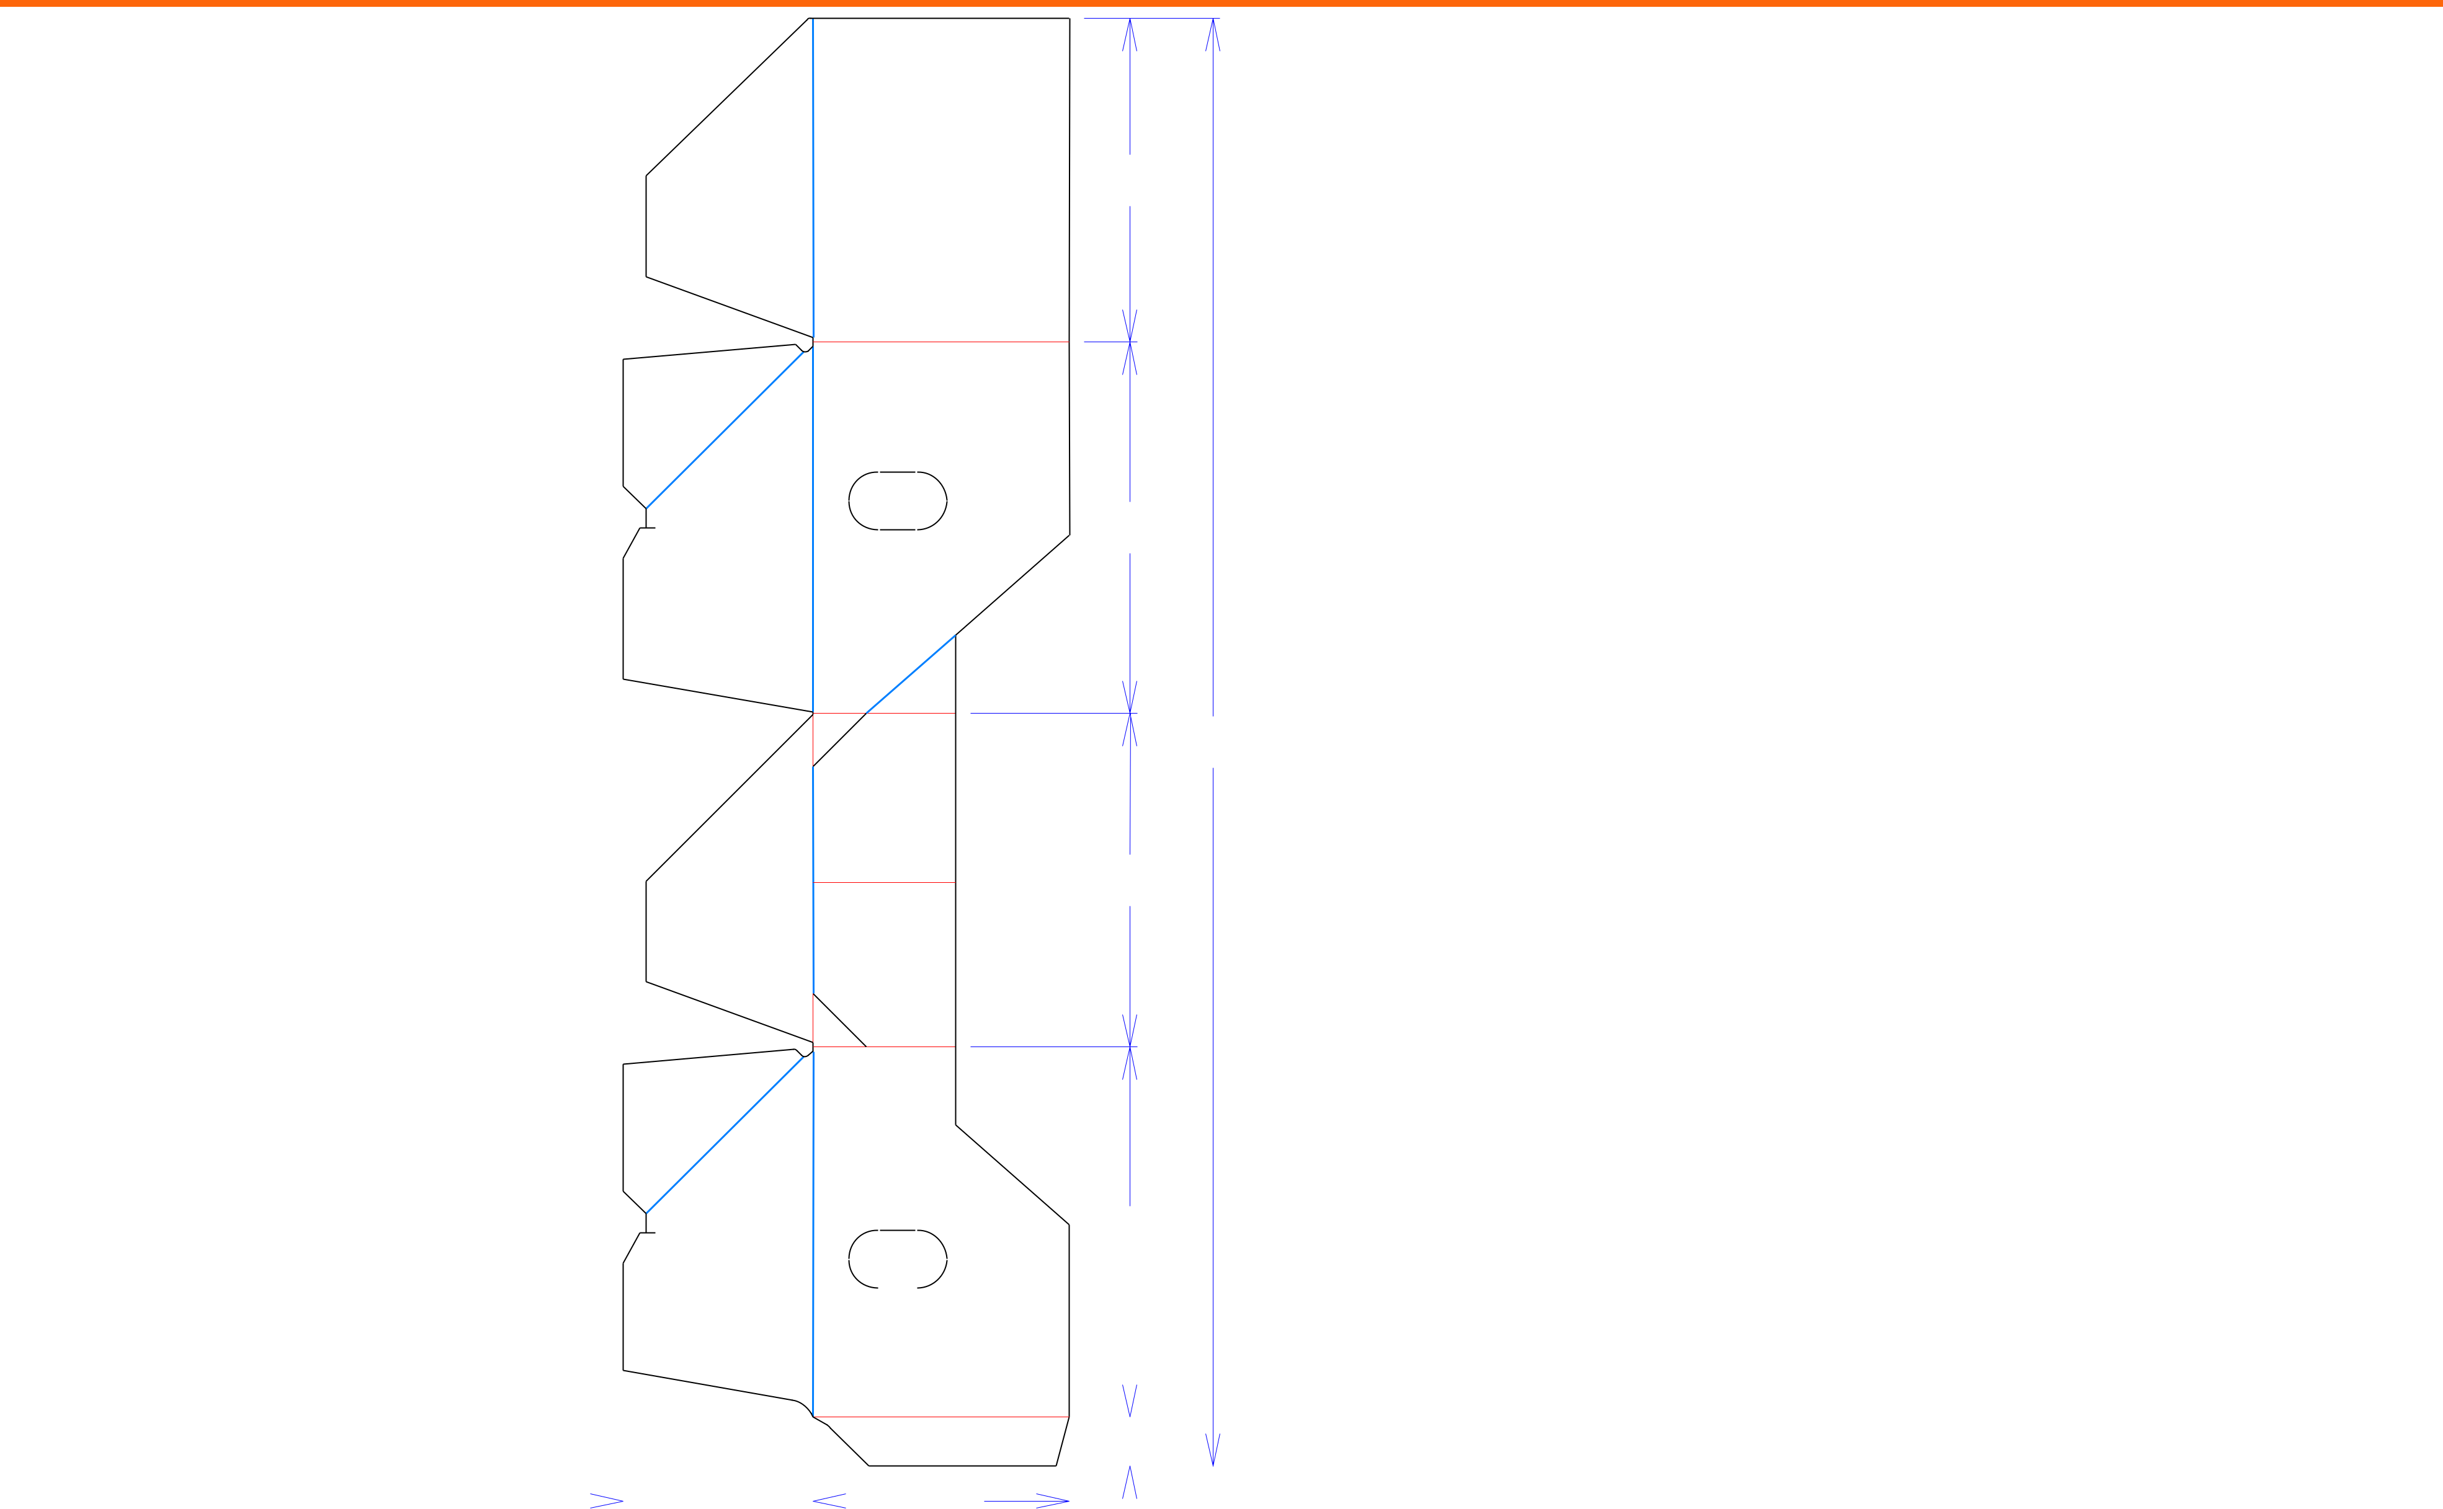

93*/*32

107*/*16

4011*/*16

93*/*8

 4 

11*/*2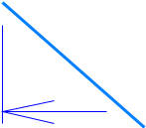

1013*/*32

|  |  |  |  |  |  |  |  |  |  |  |  |  |  |  |  |  |  |  |  |  |  |  |  |  |  |
| --- | --- | --- | --- | --- | --- | --- | --- | --- | --- | --- | --- | --- | --- | --- | --- | --- | --- | --- | --- | --- | --- | --- | --- | --- | --- |
|  |  |  |  |  |  |  |  |  |  |  |  |  |  |  |  |  |  |  |  |  |  |  |  |  |  |
|  |  |  |  |  |  |  |  |  |  |  |  |  |  |  |  |  |  |  |  |  |  |  |  |  |  |
|  |  |  |  |  |  |  |  |  |  |  |  |  |  |  |  |  |  |  |  |  |  |  |  |  |  |
|  |  |  | 511*/*32 |  |  |  |  | 73*/*16 | | |  | 13*/*8 | | | |  |  |  |  |  |  |  |  |  |  |
|  |  |  |  |  |  |  |  |  |  |  |  |  |  |  |  |  |
|  |  |  |  |  |  |  |  |  |  |  |  |  |  |  |  |  |
|  |  |  |  |  |  |  |  |  |  |  |  |  |  |  |  |  |  |  |  |  |  |
|  |  |  |  |  |  |  |  |  |  |  |  |  |  |  |  |  |  |  |
|  |  |  | 1217*/*32 | | |  |  |  |  |  | Tear Tape | | | | | | | Perforation |  |
|  |  |  |  |  |  |  |  |  |  | Half Knife Cut | | | |  |
|  |  |  |  |  |  |  |  |  |  |  |
|  |  |  |  |  |  |  |  |  |  |  |
| Cut | Crease | Crease with Matrix | | |  |  | Cut Crease | | | | |  |  |
|  |  |  |  |  |  |  |  |  |  |  |  |  |  |  |  |  |  |  |  |  |  |  |  |  |  |



Design#:

**200140-01**

Customer:

**DeMet's Candy**

Description:

**TTLS 10x6.4oz DCA Giftbox Holiday DRC - Tray**

**SINGLE-OUT DRAWING**

Qty/Unit:

Style: **PJDC**

Board: **32EW**

Combination: **36MW - 23M - 35HP**

I.D. : **10+3/8 x 9+5/16 x 7+1/8**

**O.D.: 101/2 x 97/16 x 71/4**

Area of Blank - Waste : **2.74 sq. ft.**

Waste on Blank : **22.68%**

Finished Piece Weight: **0.28 lbs./127.26g**

Over-all Blank: **40+11/16 x 12+17/32**

**Matrix ALL Scores**

**X= Crush Areas Required**

Notes:

**10+3/8 x 9+5/16 x 7+1/8**

Revision Info: **[0] 02/24/2020**

Designer: **Amy Kirchhoff**

Designright and Copyright of DS Smith Corrugated Packaging Ltd. This technical Specification is subject to Manufacturing tolerances. Drawing dimensions shown are crease to crease. Date printed: 02/26/2020